Responding & Reporting a Safeguarding
Concern Process & Procedure June 2024

If you have a concern, doing NOTHING is not an option. It is not your job to investigate the disclosure, but you do have a responsibility to respond & report appropriately. In the event of a young person or adult at risk putting their trust in you, you need to understand how hard it has been for them to tell & give them confidence that you take it seriously & know what to do next.
Concerns raised by a third party also need to be recorded & reported.

Try to:
• Remain Calm
• Listen Carefully & don’t interrupt.
• Explain early that you can’t keep the details to yourself & that others are there to help. If they are adamant, you will need to discuss it further with the Blandford & District Angling Club Welfare Officer (BDAC) &/or the Angling Trust Lead Safeguarding Officer.
• Allow them to continue at their own pace.
• Don’t ask leading questions. Tell me, Explain, Demonstrate. (TED)
• Reassure them they are not to blame they have done nothing wrong.
• Try to protect evidence, photos of injuries, clothing, etc.
• Record in writing as soon as possible using their own words on the Incident Reporting Form.
- Make sure you record date, time & as much detail as you can. Keep it locked away.
• Contact the Blandford & District Angling Club Welfare Officer &/or the Angling Trust Lead Safeguarding Officer & send them the completed Incident Reporting Form who will liaise with each other.

Do Not:
• Panic, show alarm or shock.
• Ask questions that lead. Just questions for clarification.
• Speculate, make assumptions or judgements.
• Make promises or keep secrets.
• Make comments about the abuser.
• Share it with other people other than officers that can know.
• Delay in reporting it.
• Keep it to yourself.

- If you are unsure contact the BDAC Welfare Officer or a member of Angling Trust Safeguarding team.
- If you feel that the person is in immediate danger, dial 999.
- Angling Trust Safeguarding Officers can make help inform decisions about suspensions & make full investigations.
- Remember it is not your role to investigate whether abuse has taken place or not, but it is your responsibility to report it.

Useful Contacts:
Blandford & District Angling Club
Welfare Officer: David O’Loughlin
Email: blandfordangling@outlook.com
Phone Number: c/o Pete Brundish (Secretary) 07867 988306
Angling Trust Safeguarding Officers:
Lead Safeguarding Officer: Richard.hadley@anglingtrust.net
Deputy Safeguarding Officer: Darren.birch@anglingtrust.net
Competitions Officer: kelly.latimer@anglingtrust.net

Recognise Respond Record Report
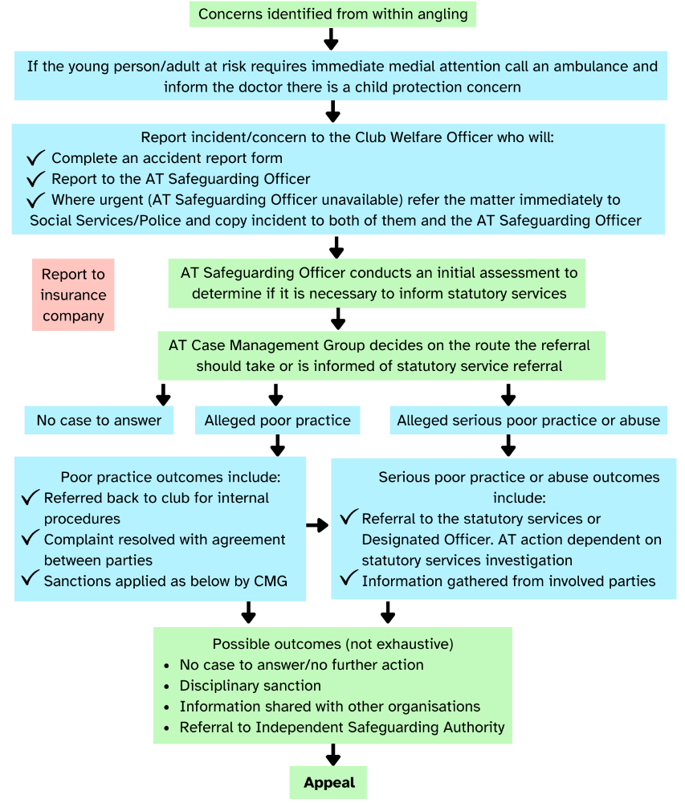
Process for Reporting Concerns

